KEVIN BURT - HEARTLAND & SOUL (Little Village Foundation- Oct ’18)
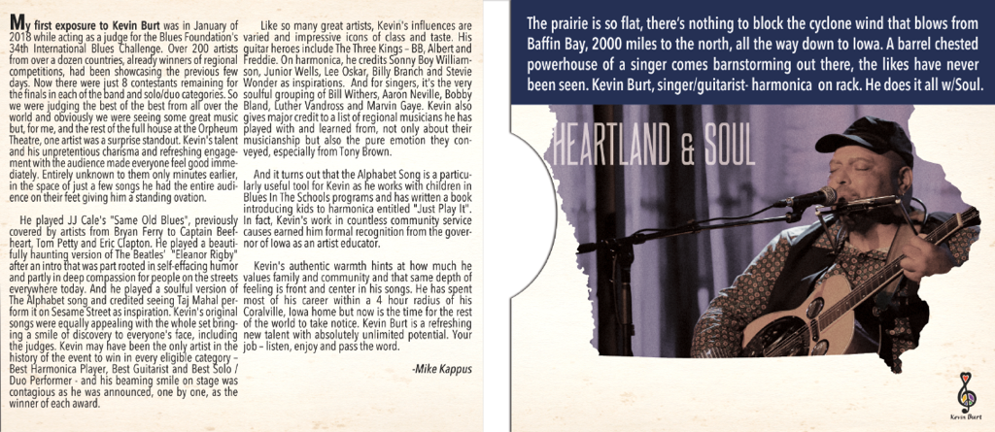
2018 International Blues Challenge Winner in 3 categories!!
1st place Solo/Duo, best Solo/Duo guitarist, & best harmonica player award!!
BIG MAN, BIG VOICE, BIG HEART, BIG LOVE!
We’re very excited to share this huge musical talent to the world with this much-anticipated, stunning debut recording from Kevin Burt - HEARTLAND & SOUL! The Iowa based Burt’s vocals are absolutely amazing – extremely powerful, rich, warm, expressive and exploding with SOUL!! Another killer sounding album recorded at Kid Andersen’s famed GREASELAND Studios in San Jose’, CA, with a golden touch from guitarist/producer Kid and producer/keyboard master/Little Village Foundation’s Jim Pugh.
The all-star band features an incredible rhythm section with D’Mar Martin on drums, Jon Otis (Johnny Otis’ son!) on percussion, and the bassist to the stars, Jerry Jemmott! Grammy award winning Jemmott is a true living legend, playing on so many timeless soul, blues, & jazz classics, from B.B. King’s “Thrill Is Gone” to Gil Scott Heron’s “The Revolution Will Not Be Televised” to Aretha Franklin’s “Think”- be sure to check out Jerry’s unbelievably rich and varied eye-popping discography.
These are all outstanding Kevin Burt original roots/blues recordings, save for a really cool stripped-down but intense cover of “Eleanor Rigby” that the charismatic Burt makes all his own like all true artists do. His award-winning blues harp playing is featured throughout, highlights include the “Wake Up, Baby” and the catchy, upbeat standout opener, “Real Love.” And “Smack Dab In The Middle” starts off with a down and dirty Delta blues feel with harp and slide guitar, and then segues into a monster funk soul groove. Be sure to check out the ultra-funky “I’ve Been Watching You” and “Day Day,” along with his seductive plea to his lady “Never.” This beautiful sounding record will now show the world why this rising star dominated the 2018 International Blues Challenge competition!

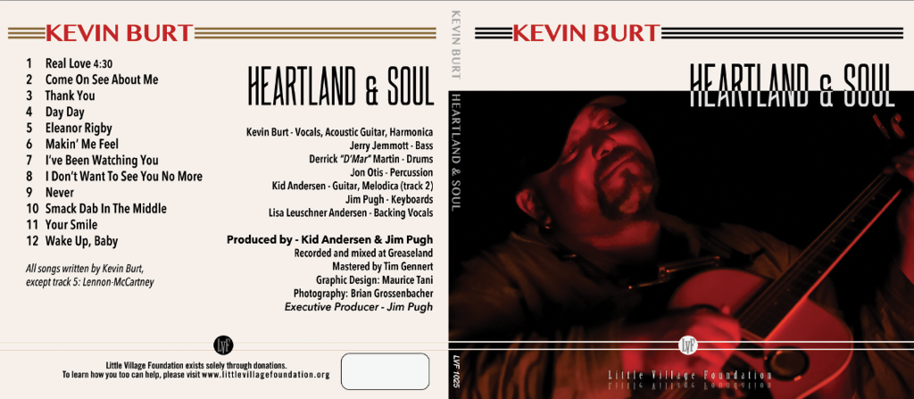
“In this day and age where celebrity status is often conveyed on people with little discernible skills or talent, it is refreshing when the spotlight finally lands on someone who has worked hard, paid their dues, and actually deserves recognition for their talent. Such is the case with Kevin “B.F.” Burt,” the singer and multi-instrumentalist who created quite a buzz on Beale St. in Memphis during the first three days of this year’s International Blues Challenge, winning 3 awards !! – 1st place in the Solo/Duo category, the Cigar Box Guitar Award for best guitarist in Solo/Duo category, and the Lee Oskar Award for best harmonica player!”
- Mark Thompson, BLUES BLAST MAGAZINE

For upcoming live performances, including a fascinating and unique midwestern grocery store tour, be sure to check out Kevin Burt’s website…
www.bfburt.com www.littlevillagefoundation.com
“His unique delivery ranges from the sweetest, fullest, juiciest come-on to the most playful growl.”
www.dmarmusic.com www.jerryjemmott.com www.jonotis.com

Press/Publicity/Radio: Kevin Johnson Proud Papa Promotions & Publicity
delrayjohnson@yahoo.com 773.742.4327 5840 N. Drake, Chicago, IL 60659

